Doug Schulte

nyu-info-2335

"Freestyle" Project Planning and Requirements Document

**Problem Statement:**

I grew up in Oregon on the west coast. Growing up, we would spend a lot of time outside, especially in the woods near where I lived. As I got older, my friends and I got more adventurous and would seek out the best hikes we could find in the area. A lot of the time, it meant taking a paper map and kind of getting lost.

I moved to New Jersey in 2016 and quickly found that a lot of Northeasterners did not have that same experience. My co-workers joked that I worked at REI on the weekend, just because I managed to find a lot of good (and bad) trails in the area. I would often get questions from people if they wanted to go for a hike, because they did not have an understanding of where to start or how to judge the hikes they found through the myriad of resources online.

For this project, I decided that I should create a tool to help these people. My problem statement will be: *Novice hikers need a way of finding quality hikes with appropriate difficulty levels, so that they can easily find an enjoyable hiking route and feel more confident about getting on the trail*.

Currently, there are hundreds of websites and blogs online that detail hikes around the northeast, but there is not a good standard. Most only contain a small number of hikes in an area and do not measure hikes against one another. If websites do compare hikes, there’s generally not a standardized measure of difficulty. What is “easy” for a trail blogger may be “really, really difficult” for a novice. Due to the confusing, competing, and significantly disorganized information on the web, I think that many would-be hikers are intimated.

There is a relatively new tool online named the Hiking Project, which I intend to utilize in the creation of my app. It is a crowd-sourced collection of hikes, where users can load, rate, and judge the difficulty of hiking routes. While it’s incredibly useful for hikers with more experience, it could be overkill for novices, as it could be challenging to sort through all of the information available.

**Proposed Solution:**

I want to capitalize on the information available through the Hiking Project, but make it easier for a novice user to find the right hike. I plan on creating an app that will let the user provide some basic information and then use the Hiking Project’s API to return the best hike. The app will work with the hiking project to find the highest rated hike in an area, given the user’s desired starting location and desired difficulty. The user will receive some basic data about the hike, such as length and average rating, along with a link to that site’s Hiking Project site. The goal will be to deliver the user the perfect hike without getting overwhelmed by the available information.

App displays best fit for user

App filters results

App interacts with API

In order to accomplish this goal, there are several pieces of functionality that need to be built into the app. The app must accept inputs from the user detailing their location, their preferred search radius, and what their desired difficulty level is. The app must then be able to then interact with the Hiking Project to find any hikes that meet the user’s location requirements. The app must then be able to refine the results to account for each hike’s difficulty level. The app must then be able to display some information about the highest rated hike that met the user’s criteria. The app must be able to save the information provided to the user for access later.

User Inputs:

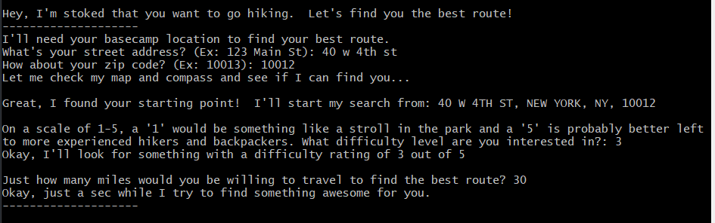

App Outputs

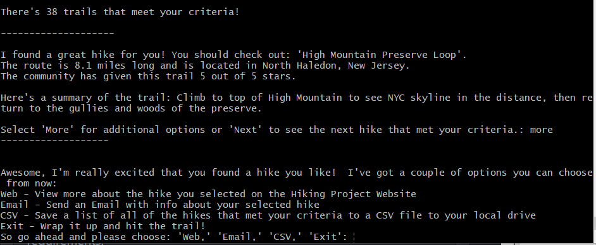

To reach the desired level of functionality. The app will need to be able to interact with multiple APIs and include a significant amount of filtering logic:

The Hiking Project API: The app will use the Requests module to query the Hiking Project API. The user will input their location and the distance that they ware willing to travel to find hikes. The user will provide a street address, which must be converted to latitude/longitude for this API. This API return a JSON containing several pieces of metadata about each hike and potentially hundreds of matching hikes. The API request is set to return the results based on the highest level of “quality.”

The US Census Bureau API: This app will use the Requests module to query the USCB API. The user will input their street address and this API is capable of returning a JSON containing the latitude/longitude of that address.

The app will parse the USCB JSON to retrieve the user’s lat/lon. These will become stored in variables. The app will then include them as part of the Hiking Project’s API request.

The app will then parse the Hiking Project’s JSON. The app will include logic to filter the results of the JSON based on the difficulty level selected by the user. List comprehension will be vital in providing the appropriate hike, as the Hiking Project API does not include any quality or distance criteria.

The user will be able to cycle through these filtered lists. The user will be prompted to view the results online, see the total list of hikes, or email the saved results.

The app will need to utilize the dotenv module to handle API credentials for the Hiking Project. The USCB’s API does not require credentials. The Sendgrid module is required for users to email their results. Sendgrid also requires an API key, which is accessed through the dotenv module.

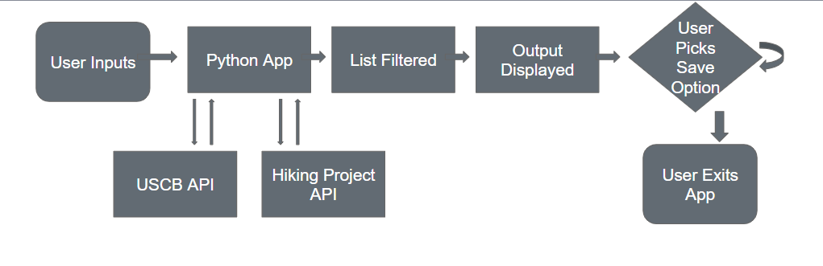

**Development Plan**:

There are several pieces to this project, so it needs to be broken down into chunks. In order, this is how I intend to work through this project.

1) Create static functionality for the Hiking Project API

2) Create static functionality for the USCB API

3) Assign user inputs to provide criteria for both APIs.

4) Parse the USCB API return JSON to provide a location variable for the Hiking Project API

5) Create a user display that provides some metadata about the hike with the highest “quality” in list

6) Filter Hiking Project API return JSON to return hikes of only selected difficulty level

7) Incorporate save features (view in web, save csv, email)

The API functionality is an absolute must for this app. List comprehension to filter results will be needed. The “save features” will be the least prioritized, but should also be the easiest part of the app.